Master Greenhouse Document

# Top-Level Block Diagram

# MPPT Box

This is an MPPT controller.

**Input:**

Voltage from Solar Panels

**Output:**

Constant voltage.

Microcontroller Data

We have a Tristar Morningstar MPPT Solar Charge controller.

Model Number: TS-MPPT-60.

We’ve got an owners manual.

It’s capable of outputting data through these formats:

RS-232

Morningstar Meter Bus

EIA-485 (formerly RS-485)

RS-232 Configurations

BAUD rate: 9600

Data bits: 8

Start bit:

Stop bit:

No parity bit

The problem: RS-232 outputs 13V for high bit and -13V for low bit.

We need to convert from RS-232 to TTL.

RS-232 is a format suited for long-range communiction.

TTL is a format suited for microcontrollers.

We can use a MAX232 IC chip to do the job.

# BMS Box

We need a battery management system.

**Input:**

Voltage from Tristar MPPT Solar Charge Controller.

**Output:**

Microcontroller Data, Constant Voltage.

If the BMS detects voltage from the MPPT controller, do this:

If the MPPT power is higher than needed by the greenhouse, route the amount of power necessary from the MPPT to the greenhouse, and the rest of the power goes to the battery. If the battery has enough space to receive the energy, send a message to the microcontroller saying the batteries are charging. If not, then send a message to the microcontroller saying the batteries are fully charged. Somehow, we have to get rid of this excess energy.

If the MPPT power is lower than needed by the greenhouse, route all the power from the MPPT To the greenhouse, and compensate the difference of power from the batteries. If the batteries don’t have enough voltage, then send a message to the microcontroller saying we don’t have enough power to run the greenhouse.

If there’s no MPPT power, then draw the necessary amount of power from the batteries.

# Batteries

At one point, the 2017 team considered Lead Acid batteries, Nickel Cadmium batteris, Nickel Metal Hydride Batteries, and Lithium Ion batteries. Here are all of their specifications:

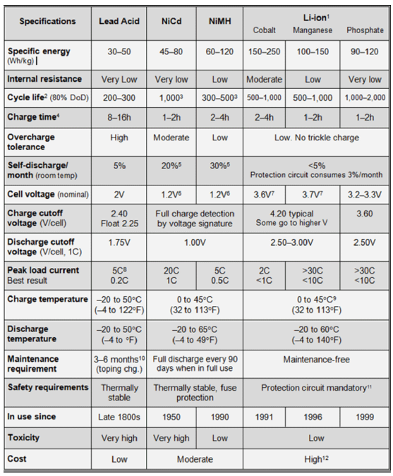

The ones that ended up being picked are lithium-ion batteries.

Model number: IEP71/180/278-CA180FT

Nominal voltage: 3.2V

Rated Capacity: 180Ah

Rated Energy: 576Wh

I think it’s this thing right here:

<https://www.alibaba.com/product-detail/3-2V-180Ah-Battery-200Ah-LiFePO4_60769977420.html?spm=a2700.7724857.normalList.14.22c11fa70X3Jaa>

# Sine Wave Inverter Box

Input: 12V DC voltage

Output: 110V 50Hz AC voltage

# Microcontroller Box

# Solar Panels

As of August 2017:

The solar panels are branded LUMO and produced by Soliculture. They have non-continuous photovoltaic cells which allow light to pass through the clear glass panels so that plants can still harvest a majority of the light. Additionally, they act as replacements for the glass roof panels of the greenhouse. (This is a terrible idea, guys. It has a bunch of leaks that need to be fixed, now.)

**Company:** Soliculture

**Panel Dimensions:** 64” x 22”

**Mounting:** Panels slot into slides on the roof and are held in place by an aluminum strap on the face that meets the wall.

**Older Panels:**

Quantity: 22

Cloudy Day:

VOC = 29.9V, ISC = 0.22A, Power: 6.6W

Sunny Day:

East Side: VOC = 31.3V, ISC = 0.50A, Power: 25.4W

West Side: VOC = 31.3V, ISC = 0.81A, Power: 25.4W

**Newer Panels:**

Quantity: 10

Cloudy Day:

VOC = 6.75V, ISC = 2.4A, Power: 16.2W

Sunny Day:

VOC = 6.84V, ISC = 4.3A, Power: 29.4W

**Panel Specifications from Manufacturer:**

VOC = 8.00V, ISC = 12.30A, Vmp = 6.30V, I­­mp = 10.80A

Power: M­pp = 68W

This is the average panel performance.

**Input:**

Sunlight

**Output:**

Average of 68W of power delivered to the MPPT controller.

Speculations for 2018:

Tela wishes for a way to track solar power. We need voltage, current, power, and light intensity. This is what she will get.

# Website